**Lab - Create a GlobalNames Zone**

**Overview**

A GlobalNames zone provides **single-label name** resolution for your DNS zone. This allows a single-label name to be translated to the IP address of a Fully Qualified Domain Name (FQDN. This allows you to replace an existing WINS server and use DNS only.

For instance, you have a server with a very long FQDN that legacy software of machines cannot resolve because they do are not equipped to use or resolve DNS queries. However, they can resolve a **single-label name**. WINS can provide **single-label name** resolution, or you could create a GlobalNames zone in DNS.

For a single-label name to IP address resolution to work, you would need to create a unique alias CNAME record for each like device in your GlobalNames zone. This, in turn, will provide a single-label name resolution for IPv4 addresses. The main drawback of using a GlobalNames zone is you must manually create a unique CNAME record for each FQDN to be able to resolve it’s IP address using a single-label name.



If you saw the following question on an M$ exam, what would be your answer?

You deploy a server named DC1 running Windows Server 2012 R2. The DNS server role is installed. You need to ensure clients computers can resolve **single-label names** to IP addresses.

What should you do?

Answer: Create a GlobalNames Zone

In this example, I’ve created a CNAME record for DC1 inside my newly created GlobalNames zone. I want to able to find DC1 using just the name, ‘server1.’ I would create additional unique CNAME records inside the GlobalNames zone for any additional servers i.e.., server2, server3 and so on.

1. By default, an authoritative DNS server uses local zone data first to respond to a query, before trying the GlobalNames zone to see if the name exists.
2. Dynamic updates that are sent to an authoritative DNS server are checked against GlobalNames zone data first before being checked against local zone data.
3. No software updates are required for clients to enable them to resolve the names that are configured in the GlobalNames zone.
4. DNS client registration is not affected unless a computer tries to register a name that is already configured in the GlobalNames zone.

**Begin the Lab**

**Enable GlobalNames Zone functionality**

To create the GlobalNames zone, use the following procedure:

1. On the primary DNS server for the forest, open Windows PowerShell.
2. Run the **Set-DnsServerGlobalNameZone –AlwaysQueryServer $true** command to enable GlobalNames zone support.

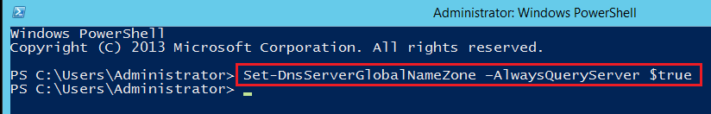

1. Run the **Add-DnsServerPrimaryZone –Name GlobalNames –ReplicationScope Forest** command to create the GlobalNames zone.

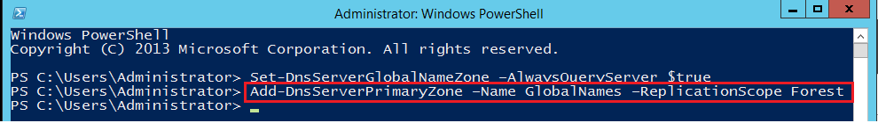

1. Open DNS Manager and locate the GlobalNames zone node.
2. Create the required CNAME records for server resources that still use single-label names.

This GlobalNames Zone Functionality must be enabled on each DNS server in the forest.

Open the DNS Management Console snap-in by opening Server Manager, expanding Tools and selecting DNS from the list of available snap-ins.

From the left window pane of your DNS Manager, expand Forward Lookup Zones; you will see your GlobalNames zone at the bottom. This was created using Powershell.

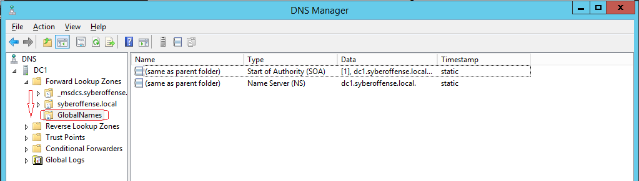

Right-click on your new GlobalNames zone and select New Alias (CNAME)… from the list.

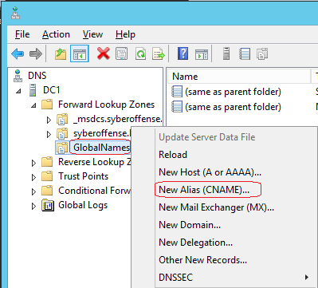

Give your record the Alias of ‘servers’ or use one of your own.

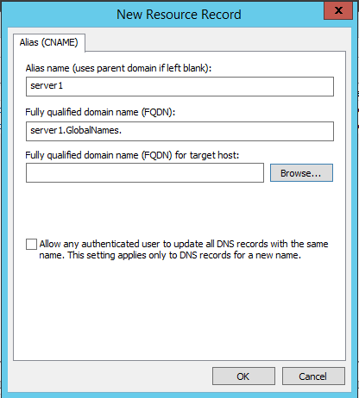

Select the DNS server that hosts your forward lookup zone for the domain.

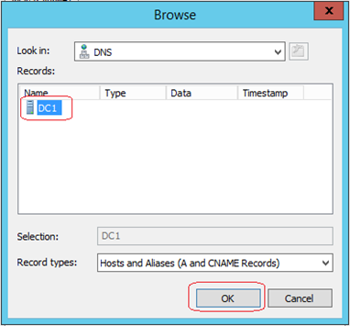

On the next window, x2 click Forward Lookup Zones

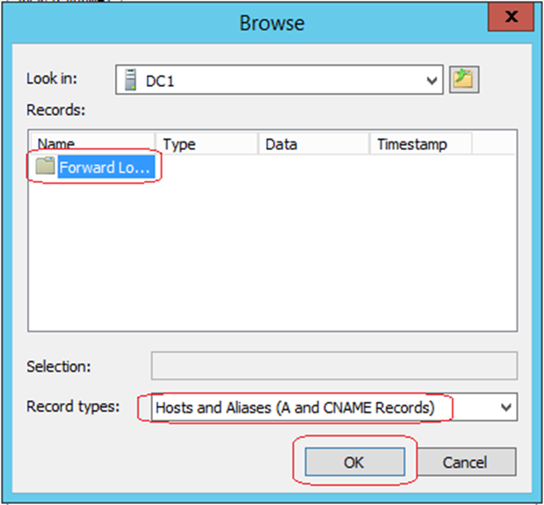

On the next window, select the name of your forward lookup zone from the list.

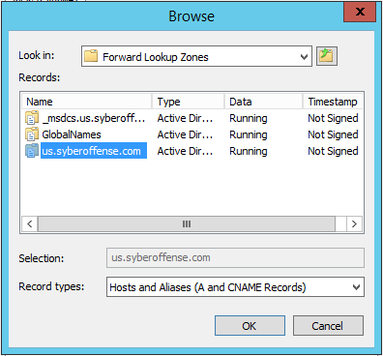

On the next windows, find the A record (FQDN) for your server. Click OK.

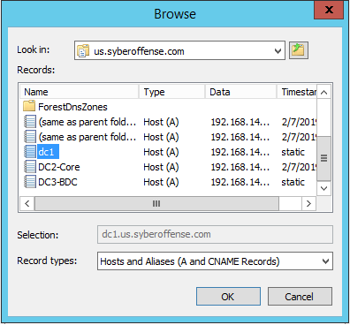

Examine the results for the new record. Click OK.

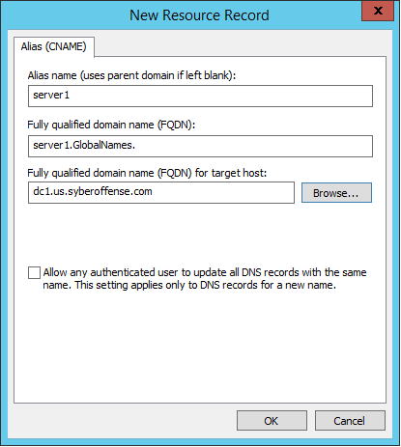

Open the GlobalNames forward lookup zone and exam the CNAME record we just built.

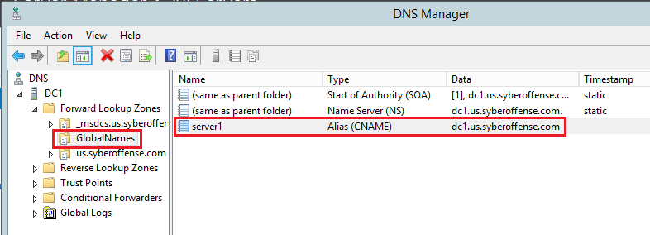

When you are done, you can restart the DNS service for the changes to take effect. To do this, right-click on the name of your DNS server, from the context menu select All Tasks and from the next context menu, select Restart.

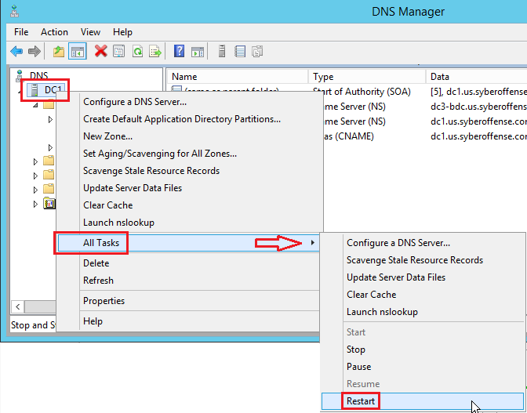

Test for Single-Label names to IP address resolution.

Bring up a command prompt on your server and try to ping the name servers.

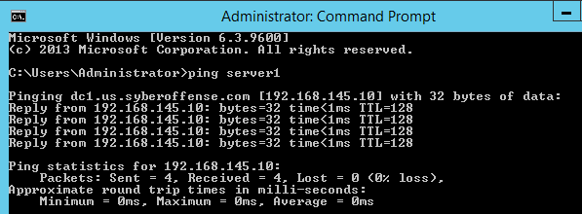

Success!

Next, type: nslookup server1

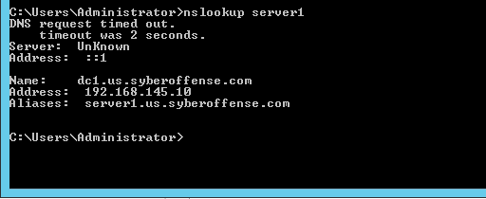

Success!

Summary

In this lab, we learned to configure a GlobalNames zone for resolving a single-label name to a Fully Qualified Domain Name. The biggest downside is having to manually create a unique individual CNAME record that maps to the Fully Qualified Domain Name of each server.

The benefit is being able to resolve the single-label name from any domain in the forest. If you had a forest with multiple domains and the server was in a domain halfway around the world, you would be able to locate the server using a single-label name. You wouldn’t have to worry about remembering the FQDN to query the server.

The main purpose of having a GlobalNames zone is to replace WINS which for most networks would not be a problem unless the network is running legacy software, Windows NT. 4.0. Windows 95, 98 or ME.

To see if your network needs WINS or the ability to resolve single-label names, you would monitor your network for NetBIOS traffic using a protocol analyzer such as Wireshark.

If you need to provide the ability to resolve a single-label name and you do not want to run WINS on the network, a GlobalNames zone could be your solution.

End of the lab!